Tuna Pasta with Olive Tapenade
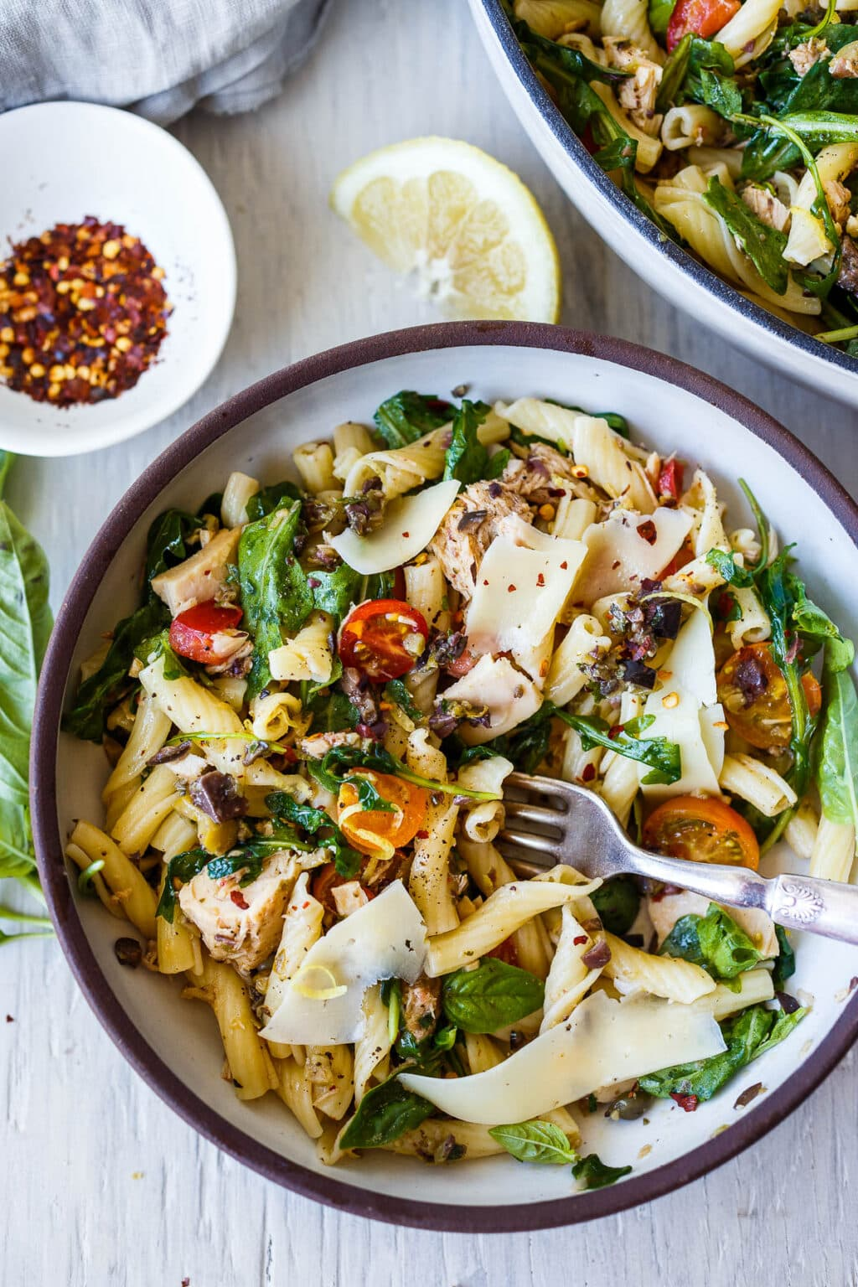
DESCRIPTION:
Tuna Pasta with Olive Tapenade & Fresh Tomatoes is a super fast, fresh pasta dish that is full of bright clean and savory flavors. An easy meal ready in 30 minutes! Healthy, quick and delicious!

INGREDIENTS:
8 oz pasta like fusilli, torchetti, bow ties- something that hangs on to the bits and pieces
3 garlic cloves minced
1/4– 1/2 teaspoon red pepper flakes
2 tablespoons olive oil, divided
3/4 cup olive tapenade
2 cans good quality tuna, 5 oz (in olive oil preferred)
2 teaspoon lemon zest
2 cups fresh arugula
1/4 cup lemon juice
1 1/2 cups fresh tomatoes, chopped
1/2 cup fresh basil or parsley
salt and pepper
Cook Mode Prevent your screen from going dark

INSTRUCTIONS:
Cook pasta according to package directions in salted water. Do not rinse.
Make the Olive Tapenade.
Sauté garlic, pepper flakes, and olive oil for a few minutes until it smells fragrant and barely begins to color. Add olive tapenade, tuna and the oil, and lemon zest and heat to warm, about a minute.
Add hot pasta, arugula, lemon juice (start with 1/8 cup and add more to taste), stir to combine. Add tomatoes, sprinkle on fresh basil and add salt and pepper to taste.

NUTRITION:
Serving Size
Calories: 327
Sugar: 2.4 g
Sodium: 158.4 mg
Fat: 11.9 g
Saturated Fat: 1.9 g
Carbohydrates: 32.4 g
Fiber: 2.5 g
Protein: 22.4 g
Cholesterol: 10.3 mg

